**Sales Performance Dashboard**

**Prepared by: Malin M, malinmayalal@gmail.com,9496017636.**

**1. Overview**

This Sales Performance Dashboard provides insights into revenue, profit, sales distribution, and product line performance.

It enables users to filter data based on Product Line, City, Branch, and Customer-Type.

**Sales Data Analysis**

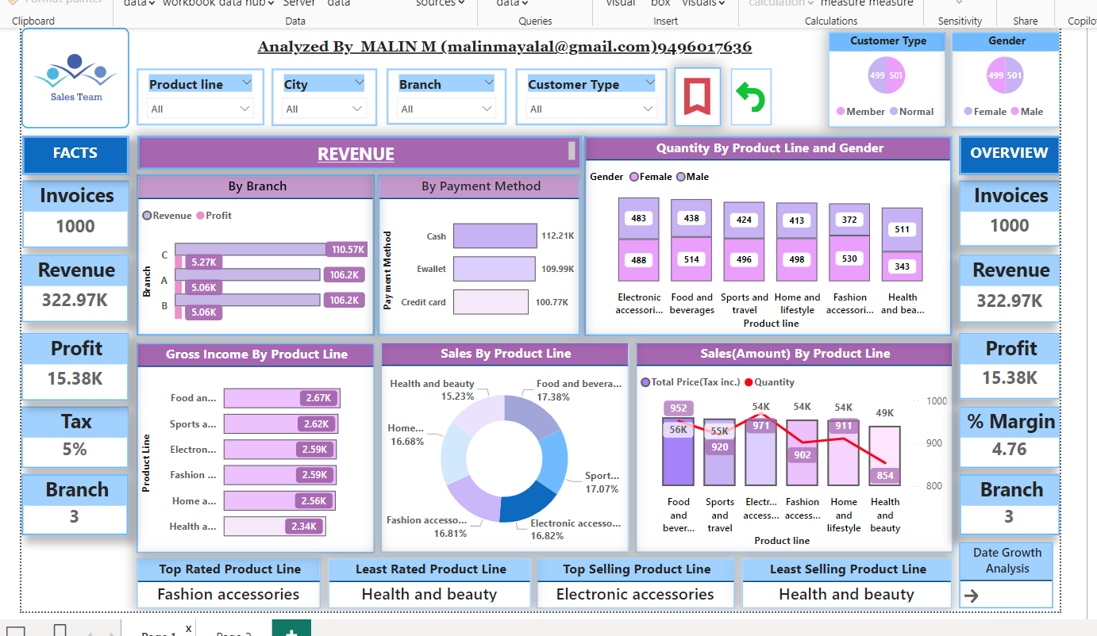

**Month-Wise Analysis**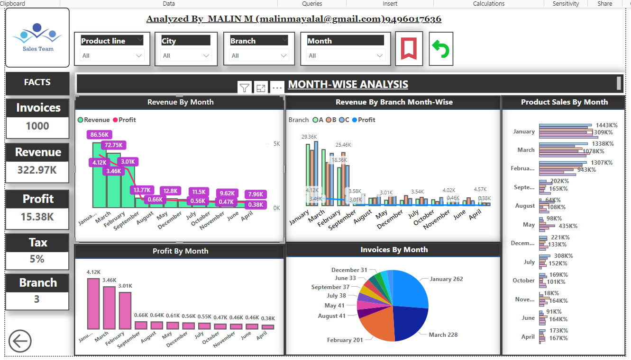

**2. Objectives**

The main goals of this dashboard are:

To monitor revenue, profit, tax, and margins.

To Analyse sales performance by Branch, Payment Method, and Product Line.

To track product line performance (best and least-selling items).

Analysis report based on the Month.

**3. Tools used**

Microsoft Power BI

Microsoft Excel

**4. Dashboard Components**

**Invoices**: Total number of sales transactions (1000).

**Revenue**: Total sales revenue (322.97K).

**Profit**: Net profit generated (15.38K).

**Tax**: Standard tax applied (5%).

**Margin %:** Profit margin percentage (4.76%).

**Branches:** Number of store locations (3).

**By Branch**: A bar chart comparing revenue and profit across Branches A, B, and C.

**By Payment Method**: Breakdown of total revenue collected via Cash, E-Wallet, and Credit Card transactions.

**Quantity Sold by Product Line & Gender**: Bar chart showing how many units of products were purchased by Male and Female customers.

**Gross Income by Product Line**: A Bar chart displaying gross profit from each product category.

**Sales Distribution (Pie Chart):** A visual representation of each product line's contribution to total sales.

**Top Rated Product Line**: Fashion Accessories

**Least Rated Product Line**: Health and Beauty

**Top Selling Product Line**: Electronic Accessories

**Least Selling Product Line**: Health and Beauty

**5. Insights**

Branch C generates the highest revenue and profit.

Cash payments are the most popular payment method, followed by E-Wallets.

Fashion Accessories is the highest-rated product category, while Health and Beauty have the least sales.

Electronic Accessories is the top-selling product line, suggesting high demand.

Female customers tend to buy slightly more than male customers across multiple product lines.

Top 2 Products Purchased by Female Customers are Fashion accessories and Food & Beverages.

Top 2 Products Purchased by Male Customers are Health & beauty and Electronic accessories.

Highest Revenue and Profit gained on January Month.

January Month attained the Maximum number of Sales.